**Project Planning Phase**

**Project Planning Template (Product Backlog, Sprint Planning, Stories, Storypoints)**

|  |  |
| --- | --- |
| Date | 19 November 2022 |
| Team ID | PNT2022TMID00757 |
| Project Name | Machine Learning-Based Predictive Analytics for Aircraft Engine |
| Maximum Marks | 8 Marks |

**Product Backlog, Sprint Schedule, and Estimation (4 Marks)**

|  |  |  |  |  |  |  |
| --- | --- | --- | --- | --- | --- | --- |
| **Sprint** | **Functional**  **Requirement (Epic)** | **User Story Number** | **User Story / Task** | **Story Points** | **Priority** | **Team Members** |
| Sprint-1 |  | USN-1 | Download and pre-process the data set | 1 | High | Suman,Rahul,Yogesh |
| Sprint-2 |  | USN-2 | Train the model | 2 | High | Suman,Yogesh |
| Sprint-3 |  | USN-3 | Train, validate the dataset in the IBM Watson | 3 | Low | Rahul |
| Sprint-4 | Predict the engine’s remaining cycle from by entering inputs in created application | USN-4 | Develop app using flask and deploy using IBM Watson. | 5 | Medium | Vajram  Suman,Rahul,Yogesh, Rakesh. |

**Project Tracker, Velocity & Burndown Chart: (4 Marks)**

|  |  |  |  |  |  |  |
| --- | --- | --- | --- | --- | --- | --- |
| **Sprint** | **Total Story Points** | **Duration** | **Sprint Start Date** | **Sprint End Date (Planned)** | **Story Points**  **Completed (as on**  **Planned End Date)** | **Sprint Release Date (Actual)** |
| Sprint-1 | 20 | 6 Days | 24 Oct 2022 | 29 Oct 2022 | 20 | 29 Oct 2022 |
| Sprint-2 | 20 | 6 Days | 31 Oct 2022 | 05 Nov 2022 | 20 | 05 Nov 2022 |
| Sprint-3 | 20 | 6 Days | 07 Nov 2022 | 12 Nov 2022 | 20 | 12 Nov 2022 |
| Sprint-4 | 20 | 6 Days | 14 Nov 2022 | 19 Nov 2022 | 20 | 19 Nov 2022 |

**Velocity:**

Imagine we have a 10-day sprint duration, and the velocity of the team is 20 (points per sprint). Let’s calculate the team’s average velocity (AV) per iteration unit (story points per day)

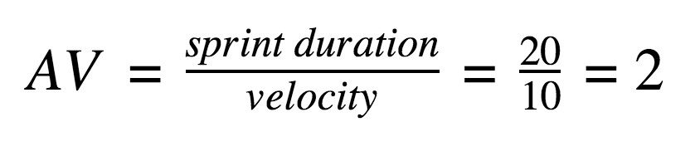

**Burndown Chart:**

A burn down chart is a graphical representation of work left to do versus time. It is often used in agile [software development](https://www.visual-paradigm.com/scrum/what-is-agile-software-development/) methodologies such as [Scrum.](https://www.visual-paradigm.com/scrum/scrum-in-3-minutes/) However, burn down charts can be applied to any project containing measurable progress over time.

[**https://www.visual-paradigm.com/scrum/scrum-burndown-chart/**](https://www.visual-paradigm.com/scrum/scrum-burndown-chart/) [**https://www.atlassian.com/agile/tutorials/burndown-charts**](https://www.atlassian.com/agile/tutorials/burndown-charts)

**Reference:** [**https://www.atlassian.com/agile/project-management**](https://www.atlassian.com/agile/project-management) [**https://www.atlassian.com/agile/tutorials/how-to-do-scrum-with-jira-software**](https://www.atlassian.com/agile/tutorials/how-to-do-scrum-with-jira-software) [**https://www.atlassian.com/agile/tutorials/epics**](https://www.atlassian.com/agile/tutorials/epics) [**https://www.atlassian.com/agile/tutorials/sprints**](https://www.atlassian.com/agile/tutorials/sprints) [**https://www.atlassian.com/agile/project-management/estimation**](https://www.atlassian.com/agile/project-management/estimation)

[**https://www.atlassian.com/agile/tutorials/burndown-charts**](https://www.atlassian.com/agile/tutorials/burndown-charts)